Mid Term
Statistical Methods and Probability
Theory part
Pdf – 1
1. Define Statistics.
Statistics simply means numerical data, and is field of mathematics that generally deals with collection of data, tabulation, and interpretation of numerical data.

2. Important of Statistics.
- Importance of Statistics in Business and Industry
- Importance in the Field of Science and Research
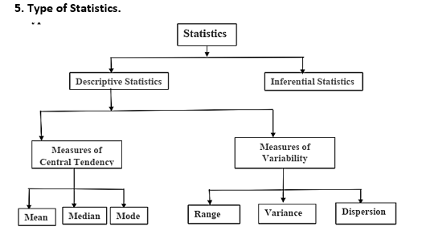
- Importance in the Field of Banking
- Importance in planning

3. Scope of Statistics.
- Presents facts in numerical figures
- Presents complex facts in a simplified form
- Helps in the formulation of policies
- Provides techniques for testing of hypothesis

4. Limitations of Statistics.
- Statistics is Useful for Experts Only
- Statistical Results are not exact
- Statistics Deals with Aggregates Only

Pdf – 2
6. Define Measures of Central Tendency.
A measure of central tendency describes a set of data by identifying the central position in the data set as a single value. Mean, median, and mode are the measures of central tendency.

7. Define Arithmetic Mean with example.
When add up all the values and divide by the number of values it is called Arithmetic Mean.
Example: What is the mean of 3, 5, 9, 5, 7, 2?
Now add up all the given numbers:
3 + 5 + 9 + 5 + 7 + 2 = 31
Now divide by how many numbers are provided in the sequence:
31 / 6 = 5.16

8. Define Geometric Mean with example.
The geometric mean of two numbers x and y is √𝑥𝑦. If you have three numbers x, y, and z, their geometric mean is ³√𝑥𝑦𝑧.
Example: Find the geometric mean of 4 and 3?
𝐺𝑒𝑜𝑚𝑒𝑡𝑟𝑖𝑐 𝑚𝑒𝑎𝑛 = √4 × 3.
= 3.46
9. Define Harmonic Mean with example.
The harmonic mean is used to average ratios. For two numbers x and y, the harmonic mean is 2𝑥𝑦/ (𝑥+𝑦). For, three numbers x, y, and z, the harmonic mean is (𝑥𝑦+3𝑥𝑦𝑧 𝑥𝑧+𝑦𝑧).

10. Define Mean.
The mean is also known as the average, and it is calculated by adding up all the values in a data set and dividing by the total number of values.

Pdf – 3
Set and Operations
1. Universal set:
An universal set is the set of all elements that may possibly be considered in a particular discussion.

𝑈 = {𝑥|𝑥 𝑖𝑠 𝑡𝑜𝑡𝑎𝑙 𝑛𝑢𝑚𝑏𝑒𝑟 𝑜𝑓 𝑠𝑝𝑜𝑡𝑠 𝑢𝑝𝑝𝑒𝑟𝑚𝑜𝑠𝑡 𝑜𝑛 𝑡ℎ𝑒 𝑡𝑤𝑜 𝑑𝑖𝑐𝑒}

2. Venn diagram:
A helpful scheme to illustrate the relationship between sets and set operations.

3. Empty set:
Any set that has no element in it is called an empty, or null set, designated with Ø.

4. Subset:
A set A is a subset of the set B if and only if for each 𝑥 ∈ 𝐴, then 𝑥 ∈ 𝐵.
The set 𝐴 = {1,2,3} is a subset of the set 𝐵 = {1,2,3,4,5,6,7}
5. Proper subset:
𝐴 ⊂ 𝐵
The set 𝐴 = {1,2,3} is a subset of the set 𝐵 = {1,2,3,4,5,6,7} Then 𝐴 ⊂ 𝐵

6. Equal set:
Two sets A and B are said to be equal, or 𝐴 = 𝐵, if and only if 𝐴 ⊆ 𝐵 and 𝐵 ⊆ 𝐴

7. Finite and infinite sets:
A set is called finite if its elements are equal in number to some specifiable nonnegative integers.
A set is called infinite if the number of its elements is greater than any positive integer.

Operation with sets
8. Intersection:
Given the sets A and B, which are subsets of U, the intersection of A and B written as 𝐴 ∩ 𝐵.
𝐴 ∩ 𝐵
If two set have no common element then they are said to be disjoint set.

9. Union:
The union of two sets A and B is the set of all elements belonging to A or B or both. Symbolically denoted by 𝐴 ∪ 𝐵
𝐴 ∪ 𝐵
10. Complementation:
The complement 𝐴̅ of a set A is defined to be a set that contains all outcomes in the universal set U which do not belong to A.
Symbolically,
𝐴̅ = {x|x ∈ U, x ∉ A}
11. Class of sets:
The set 𝐴 = {{𝑎}, {𝑏}, {𝑐}, {𝑑, 𝑒}} is a family or class of sets.

12. Power set:
If 𝐴 = {1,2,3}, then the power set of A is
Ø(𝐴) = {Ø, {1}, {2}, {3}, {1,2}, {1,3}, {2,3}, {1,2,3}}
- 2^{𝑛} elements
13. Cartesian product set:
Let A and B be two sets. The product set of A and B, denoted by 𝐴 × 𝐵, contains all ordered pairs (𝑥, 𝑦), where 𝑥 ∈ 𝐴, 𝑦 ∈ 𝐵.
Example: let 𝐴 = {1,2,3} and 𝐵 = {4,5}. Then the product set of A and B is
𝐴 × 𝐵 = {(1,4), (1,5), (2,4), (2,5), (3,4), (3,5)}

Algebra of Sets

Cumulative laws:
1. 𝐴 ∪ 𝐵 = 𝐵 ∪ 𝐴
2. 𝐴 ∩ 𝐵 = 𝐵 ∩ 𝐴

Math Topic
Pdf – 2
Mean
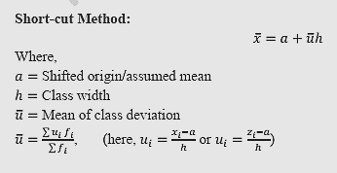
Formula:
1. Mean = Sum of all observations / Number of observations
2. Mean Ungrouped Data = Let, X1, X2, X3, …………..X_{n} be n observations
𝑥 = (𝑥₁+𝑥₂ + ...+ 𝑥_{𝑛}) /𝑛
3. Mean of Grouped data =
𝑥 = (𝑥₁𝑓₁+𝑥₂𝑓₂ + ...+ 𝑥_{𝑛}𝑓_{𝑛}) / (𝑓₁ + 𝑓₂ + ...+ 𝑓_{𝑛})

Practices Math: i. page 3 – Example – ungrouped data
ii. Example 1, 2, 3, 4 (page 3-6) – Grouped data

Pdf – 3
Probability

Math : Sample space এই অংশ টুকু দেখতে পারেন। Page – 4

উপরের এগুলা টপিক বাদ,,, মিডের কোন প্রশ্ন ফাইনালে আসবে না

Final Term
## Central Tendence 2
Mean
1. Theorem:
For a set of n non-zero positive values 𝑥1, 𝑥2, … … … , 𝑥𝑛. Prove that 𝐴 ≥ 𝐺 ≥ 𝐻, where A, G and H are respectively arithmetic mean, geometric mean and harmonic mean. (Page – 06)

2. Theorem:
A variable x takes on n values which are in geometric progression. Obtain the arithmetic mean (AM), geometric mean (GM) and harmonic mean (HM) and hence show that (Page – 07)
𝐴𝑀 × 𝐻𝑀 = 𝐺𝑀2

Median

3. Odd Even Formula and Example 1,2 (Page – 09)
4. Median of Group Data Formula and Example. (Page – 10)

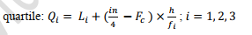
5. Measures of Position.
i. ii.
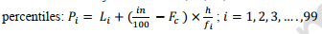
iii. ## Exercise Math (Page – 11,12,13,14 )

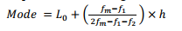
Mode
Formula: Group data (Page – 15,16,17,18 )

6. Example: example, 1, 2, 3

## Probability 03
8. Experiment -> Math (Sample space, Sample point, Simple event, Compound event.) (Page – 04)

9. Define Mutually exclusive events and probability.
Ans: Events that cannot both happen at the same time. Two or more events are mutually exclusive if the occurrence of one event prevents the occurrence of the other event(s).
Example: In a single coin flip, the event of getting heads and the event of getting tails are mutually exclusive.
Probability: 𝑃 (𝐴 ∪ 𝐵) = 𝑃(𝐴) + 𝑃(𝐵).

10. Define Complementary events.
Ans: An event A the event 𝐴̅ consisting of all points of the sample space not in A, are called complementary events.
If A and 𝐴̅ are complementary events then 𝐴 ∪ 𝐴̅ =S and 𝐴 ∩ 𝐴̅ =∅.
Counting Rules
11.
i. Permutation Exercise.
Formula: 𝑛𝑃𝑟 = 𝑛! / (𝑛 - 𝑟)!
Example: How many permutations of four letters a, b, c and d can be made taking two a time? (Page – 06)

ii. Combination Exercise.
Formula: 𝑛𝐶𝑟 = 𝑛! / 𝑟! (𝑛 - 𝑟)!
Example: There are 20 people in a room of whom 12 are men and 8 are women. A committee of 3bis to be formed from them. How many ways can this be done? (Page – 07)

Assigning Probabilities
12. Basic steps of assigning probabilities.
1. Identifying the sample space.
2. Defining the event and
3. Assigning probabilities to the event.
13. i. Classical Approach Math.
Formula: 𝑃(𝐴) = 𝑛(𝐴) / 𝑛(𝑆)
Example: A bag contains 4 white and 6 red balls. A ball is drawn at random from the bag. What is the probability that it is red? White? (Page – 07)

ii. Axiomatic Approach:
Ans: Given the sample space S and the family of events in S, each event A is real number 𝑃(𝐴), the probability of event A, such that the following axioms are satisfied:
Axiom 1: For any event A, 𝑃(𝐴) ≥ 0.
Axiom 2: 𝑃(𝑆) = 1.
Axiom 3: If A and B are two mutually exclusive events, 𝑃 (𝐴 ∪ 𝐵) = 𝑃(𝐴) + 𝑃(𝐵)
Axiom 4: If 𝐴1, 𝐴2, 𝐴3, … … … … … … , 𝐴𝑘 then
𝑃(𝐴1 ∪ 𝐴2 ∪ 𝐴3 ∪ … … … … ∪ 𝐴𝑘) = 𝑃(𝐴1) + 𝑃(𝐴2) + 𝑃(𝐴3) + ⋯ … … + 𝑃(𝐴𝑘)

Theorems on Probability
14. Theorem: 1, 2, 3, 4, 6 (Page – 8,9,10)
15. Marginal Probability: Example: Two hundred students were classified according to their faculty they belong to and their gender. (Page – 11)
16. Joint Probability: Theorem: If the events A and B are independent, and 𝐴̅ and 𝐵̅ are respectively their complementary events, then the following pairs of events are also independent:
(i) A and 𝐵̅ (ii) 𝐴̅ and B (iii) 𝐴̅ and 𝐵
(Page – 12)
## Random variable and its Probability distributions 04
17. Define Random Variable.
Ans: A random variable is a variable whose value depends on chance and cannot be predicted exactly in advance.
- A random variable is a way to quantify the results of a random event
- It maps the outcomes of a random experiment to numerical values.
18. Discrete probability distribution:
1. 𝑓(𝑥) ≥ 0
2. ∑_{𝑥} 𝑓(𝑥) = 1
3. 𝑃 (𝑋 = 𝑥) = 𝑓(𝑥)
Example: 1, 3 (Page – 3, 4)

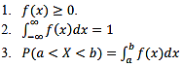
19. Continuous probability distribution:

Example: 1, 2 (Page – 6, 7)

## Mathematical Expectation 05
20. Definition of Properties of Mathematical Expectation.
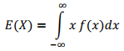
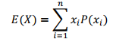
Ans: If X is a discrete random variable defined over the sample space {𝑥1, 𝑥2, … … . . 𝑥𝑛} with corresponding probabilities 𝑃(𝑥1), 𝑃(𝑥2), ………….. 𝑃(𝑥𝑛), then the expected value or the mathematical expectation of X is symbolically defined as

Properties of Expectation:
1. Linearity: 𝐸 [𝑎𝑋 + 𝑏𝑌] = 𝑎𝐸[𝑋] + 𝑏𝐸[𝑌]
2. Expectation of a constant: 𝐸[𝑐] = 𝑐
3. Multiplication by constant: 𝐸[𝑎𝑋] = 𝑎
4. If X and Y are independent: 𝐸[𝑋𝑌] = 𝐸[𝑋] ⋅ 𝐸[𝑌]

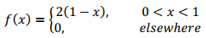
21. Example: Find the expected value of the random variable X having the following density function:
(Page – 02)

Expected value of a function of Two Random variables
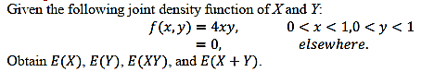
22. Example:
(Page – 03)

## Correlation 06
23. Define Correlation and type of Correlation.
Ans: The extent(degree) of the linear relationship between two variable is called correlation. Correlation analysis is a statistical tool.
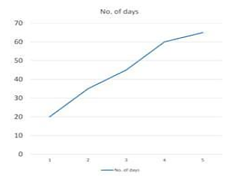
Type of / Classification of Correlation:
i. Positive and negative correlation
ii. Simple, partial and multiple correlation
iii. Linear and non-Linear

i. Positive and Negative Correlation.
Ans: This correlation is also called, direct correlation. In this, both
variables move in the same direction.
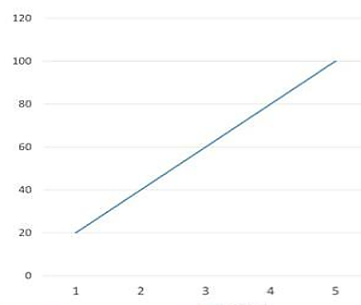
Negative Correlation.
Ans: In this, increase in one variable causes the proportionate
decrease in the other variable.

iii. Linear Correlation
Ans: Difference between these two is based on the ration of
Change between the variabels under study. Example same negative
Correlation.

Non-linear Correlation.
Ans: The amount of change in one variable doesn’t have a constant ration to the change in other related variable. Example same positive correlation.

ii. Multiple Correlations:
- In this three or more variables are studied simultaneously
- Partial and multiple correlation are mainly associated with multicariate analysis
- Relationship between agriculture production, rainfall and quantity of fertisizers used.

24. Define Correlation Coefficient.
Ans: The coefficient of correlation ‘r’ can be defined as a measure of Strength of the liner relationship between the two variables X and Y.

25. Merits vs Demerits Correlation coefficient.
Merits Correlation Coefficient | Demerits of Correlation Coefficient
It is the numerical measure of correlation | It can not be computer for qualitative data such as honesty, beauty, intelligence etc.
It also indicates the type of correlation | It meaures only linear relationship
It depends on all the observations so give true picture. | It is difficult ot calculate.

26. Application of Correlation.
Ans:
i.Agriculture:
Correlation helps to find the relationship between crops and factors like rainfall, fertilizer, and temperature. It helps farmers choose better conditions for higher crop production.
ii. Physiology:
Correlation is used to study the relationship between body measurements, such as height, weight, blood pressure, and pulse rate. It helps understand how different body characteristics are related.
iii. Genetics:
Correlation helps to study the relationship between the characteristics of parents and their children. It helps researchers understand how traits are passed from one generation to another.
iv. Medicine:
Correlation helps to find relationships between diseases and factors such as age, weight, lifestyle, or other health conditions. It helps doctors and researchers understand risk factors and improve treatment.

## Measure of Dispersion/ variability 07

Mean Deviation
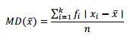
Formula 1:
[Where 𝑑𝑖 = 𝑥𝑖 – 𝑥]

Where,
𝑀𝐷(𝑥̅) = average deviation about mean
𝑘 = number of classes
𝑥𝑖 = midpoint of the i-th class
𝑓𝑖 = frequency of the i-th class

27. Math Example: 1 ( Page – 02 )

Variance and Standard Deviation
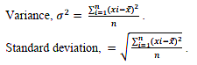
Formula 1: Ungrouped data:

*** Standard deviation = √Variance.

28. Math Example: 3, 4 ( Page – 7, 8 )

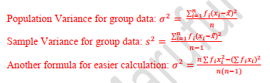
Formula 2 : Grouped Data:
Mean দেওয়া না থাকলে এই সূত্র হবে
Mean দেওয়া থাকলে এই সূত্র হবে

29. Math Example: 5, 6 (Page – 9,10)

